**Course Specialist Test 3 Year 12**

Student name: ________________ Teacher name: ________________

**Task type: Response**

**Reading time for this test : 5 mins**

**Working time allowed for this task: 40 mins**

**Number of questions: _____6______**

**Materials required:**

Standard items: Pens (blue/black preferred), pencils (including coloured), sharpener, correction fluid/tape, eraser, ruler, highlighters

Upto 3 calculators/classpads allowed

Special items: Drawing instruments, templates

No notes allowed

**Marks available: ___39___ marks**

**Task weighting: _14___%**

**Formula sheet provided: no but formulae given on page 2**

**Note: All part questions worth more than 2 marks require working to obtain full marks.**

Useful formulae

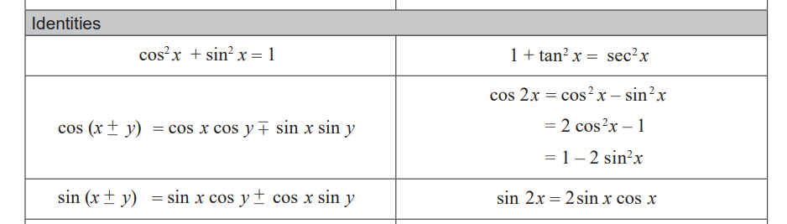

**No notes allowed**

Q1 (2, 3 & 3 = 8 marks)

An object starts from rest at the origin and moves with a velocity  m/s at time  seconds.

Determine the following.

1. Acceleration at time .
2. The cartesian equation of the path of the object. (Do not simplify)
3. Determine to the nearest second the first time for  that the acceleration and velocity are perpendicular.

Q2 (5 marks)

If   find an expression for  in terms of .

Q3 (6 marks)

Sand is poured into a gigantic metal cone of height 15 m and a radius of 4 m at a rate of 120 cubic metres per minute, as shown below.

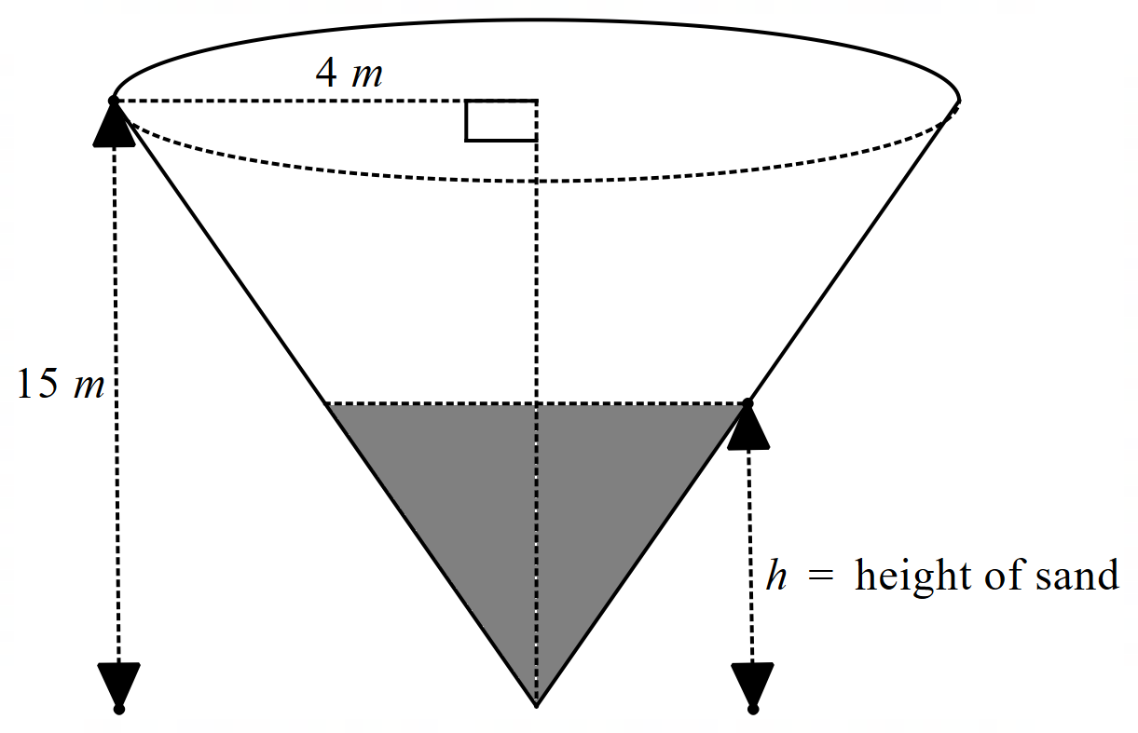

Determine the time rate of change, metres per minute, of the height, metres, of the sand when the height is 5 m.

Q4 (6 marks)

A water pipe of length 10 metres can be modelled by a cross-section 

where ,  and this curve is revolved about the x axis.

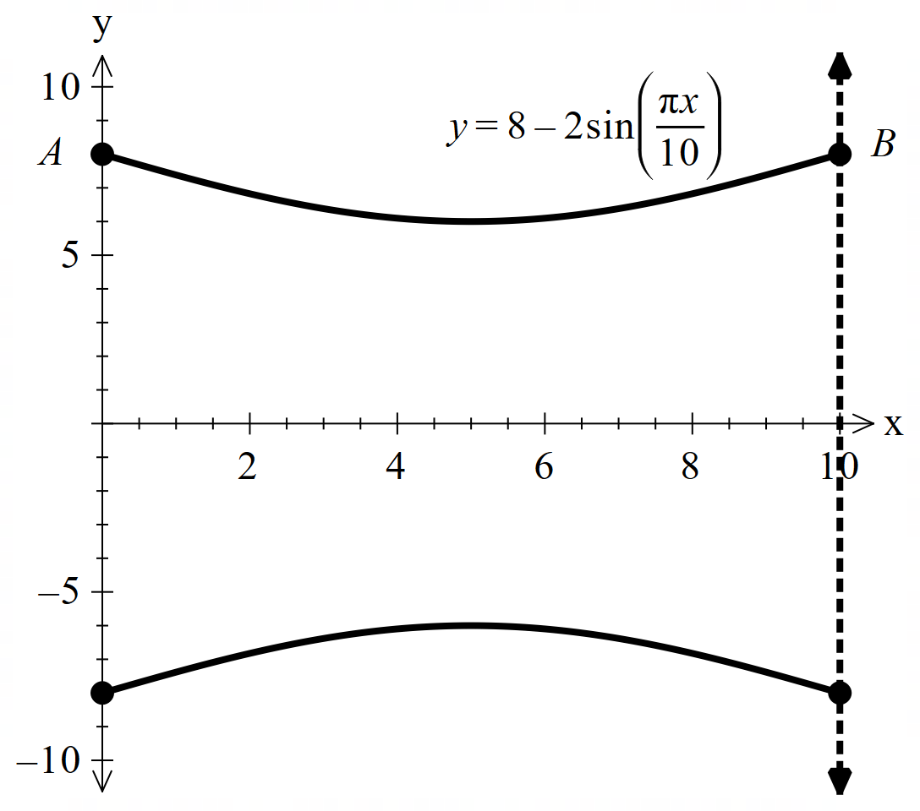

Determine the volume of water that this length of pipe will hold. Show all working **without** the use of a classpad. (Simplify)

Q5 (5, 2 & 2 = 9 marks)

At time  years, 26 kangaroos are placed in an isolated habitat such that the number of kangaroos,  can be modelled by the differential equation .

1. Using separation of variables and partial fractions determine  **without** the use of a classpad.
2. Determine the limiting value of the population of kangaroos.

Continued on next page.

Q5 cont-

1. Determine the time taken for the maximum growth rate.

Q6 (5 marks)

Consider a woman of height 1.75 m, travelling at 2 m/s along the edge of a road of width 10 m (See direction below). A lamp of height 6 m on the other side of the road, casts a shadow of the woman of length, , as shown below. Determine the **exact** time rate of change of the length of the shadow when m.

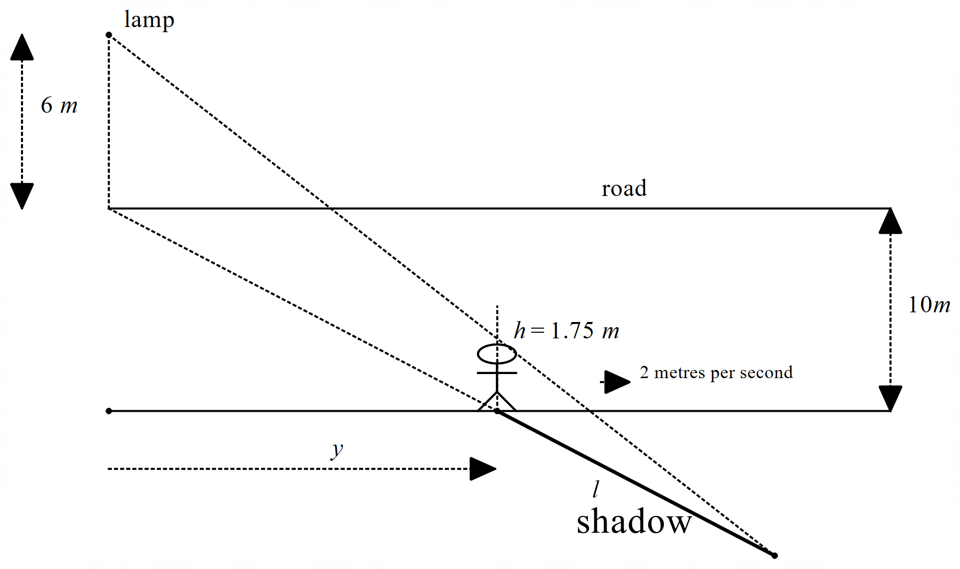

**Working out space**